Step 1: Save your inventory file
You are currently in:
-- INSERT --
Press:
ESC
Then type:
:wq
Press Enter.
You will return to the CentOS terminal.

Step 2: Check your inventory
Run:
ansible-inventory --graph
You should see something similar to:
@all:
|--@ungrouped:
|--@dev:
| |--ansibleclient1
| |--ansibleclient2
This confirms that both AWS Ubuntu servers are in the dev group.

Step 3: Test Ansible connection
Run:
ansible dev -m ping

Expected result
ansibleclient1 | SUCCESS => {
"changed": false,
"ping": "pong"
}

ansibleclient2 | SUCCESS => {
"changed": false,
"ping": "pong"
}

If you get pong
Excellent. Your Ansible setup is ready.

Practical 82 — Create a Directory
This is the first practical from your screenshot.

Step 4: Create a directory on both Ubuntu servers
On your CentOS machine, run:
ansible dev -m file -a "path=/opt/ansible-demo state=directory"
Remember:
dev
↓
ansibleclient1
ansibleclient2
So Ansible will create:
ansibleclient1
└── /opt/ansible-demo

ansibleclient2
└── /opt/ansible-demo

Step 2: Login to ansibleclient1 using the AWS Ubuntu administrator user
For a normal AWS Ubuntu instance, this is usually:
ssh ubuntu@ansibleclient1
If you use a different administrative username, use that username instead.
After login, check:
whoami
You should get:
ubuntu

Step 3: Become root
Run:
sudo -i
Check:
whoami
It must show:
root
Your prompt should look similar to:
root@ip-10-...:~#

Step 4: Now create the sudo permission
Only after whoami says root, run:
echo "ansible ALL=(ALL) NOPASSWD: ALL" > /etc/sudoers.d/ansible
Then:
chmod 440 /etc/sudoers.d/ansible
Check:
cat /etc/sudoers.d/ansible
You should see:
ansible ALL=(ALL) NOPASSWD: ALL

Step 5: Do the same for ansibleclient2
From the CentOS controller:
ssh ubuntu@ansibleclient2
Then:
sudo -i
Check:
whoami
It must say:
root
Then:
echo "ansible ALL=(ALL) NOPASSWD: ALL" > /etc/sudoers.d/ansible
chmod 440 /etc/sudoers.d/ansible
Check:
cat /etc/sudoers.d/ansible

Step 6: Return to CentOS
On both Ubuntu servers:
exit
Then:
exit
You should be back at your CentOS controller:
[ansible@server ~]$

Step 7: Test sudo through Ansible
Now run:
ansible dev -b -m command -a "whoami"
Expected:
ansibleclient1 | CHANGED | rc=0 >>
root

ansibleclient2 | CHANGED | rc=0 >>
root
If you get root on both, the problem is fixed.

Step 8: Run your Practical 82 again
Now run:
ansible dev -b -m file -a "path=/opt/ansible-demo state=directory"
Expected:
ansibleclient1 | CHANGED
ansibleclient2 | CHANGED
Then verify:
ansible dev -m command -a "ls -ld /opt/ansible-demo"

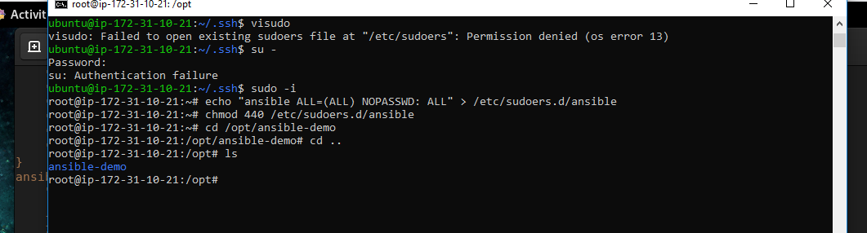

Step 5: Understand the command
ansible dev -m file -a "path=/opt/ansible-demo state=directory"

ansible
Run Ansible.

dev
Use the inventory group:
[dev]
ansibleclient1
ansibleclient2
Therefore, execute on both servers.

-m file
Use the file module.

-a
Give arguments to the module.

path=/opt/ansible-demo
Directory we want to create.

state=directory
Tell Ansible that the path should be a directory.

Step 6: Verify the directory
Run:
ansible dev -m command -a "ls -ld /opt/ansible-demo"
Expected:
ansibleclient1 | CHANGED | rc=0 >>
drwxr-xr-x ... /opt/ansible-demo

ansibleclient2 | CHANGED | rc=0 >>
drwxr-xr-x ... /opt/ansible-demo
You can also check manually.

Client 1
ssh ansible@ansibleclient1
Then:
ls -ld /opt/ansible-demo
Exit:
exit

Client 2
ssh ansible@ansibleclient2
Then:
ls -ld /opt/ansible-demo
Exit:
exit

Practical 83 — Copy a File to Remote
Now we move to the second practical in your screenshot.
The direction is:
CentOS
Ansible Controller
|
| copy
↓
ansibleclient1
ansibleclient2

Step 7: Create a file on CentOS
On CentOS:
echo "Hello from Ansible Controller" > /home/ansible/test.txt
Check it:
cat /home/ansible/test.txt
You should see:
Hello from Ansible Controller
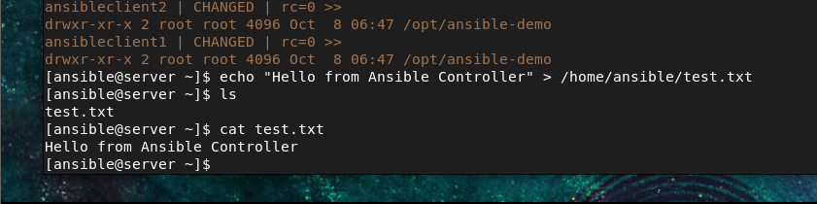

Step 8: Copy the file to both Ubuntu servers
Run:
ansible dev -m copy -a "src=/home/ansible/test.txt dest=/tmp/test.txt"
This means:
CentOS
/home/ansible/test.txt
|
| copy
↓
Ubuntu 1
/tmp/test.txt

Ubuntu 2
/tmp/test.txt
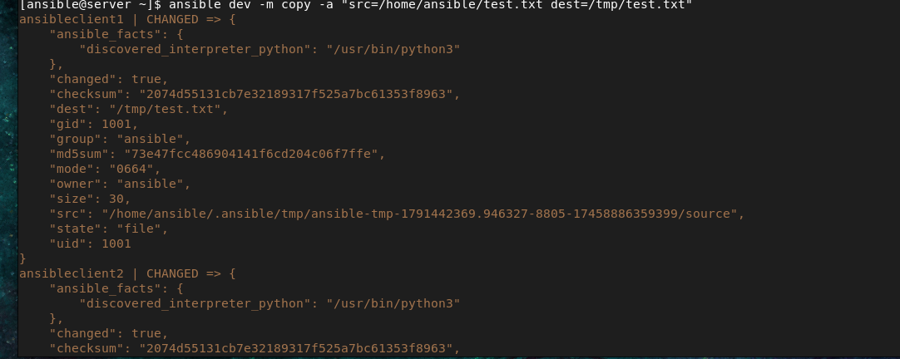

Step 9: Verify the copied file
Run:
ansible dev -m command -a "cat /tmp/test.txt"
Expected:
ansibleclient1 | CHANGED | rc=0 >>
Hello from Ansible Controller

ansibleclient2 | CHANGED | rc=0 >>
Hello from Ansible Controller

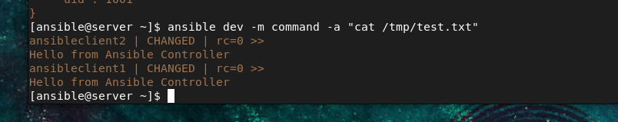
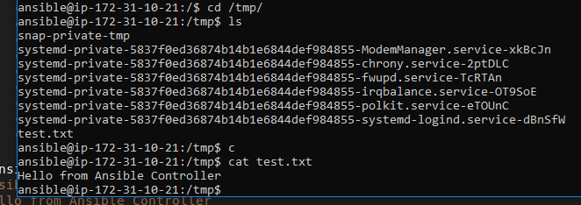

Practical 84 — Fetch File From Remote
Now we reverse the direction.
Ubuntu
↓
CentOS

Step 10: Create a file on ansibleclient1
Run from CentOS:
ansible ansibleclient1 -m shell -a "echo 'Hello from ansibleclient1' > /tmp/remote.txt"
Verify:
ansible ansibleclient1 -m command -a "cat /tmp/remote.txt"
You should see:
Hello from ansibleclient1

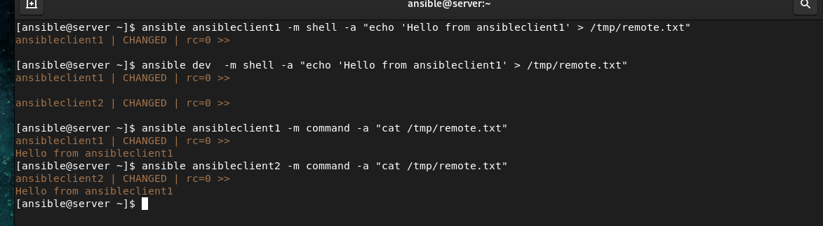

Step 11: Create a directory on CentOS
mkdir -p /home/ansible/fetched

Step 12: Fetch the file
Run:
ansible ansibleclient1 -m fetch -a "src=/tmp/remote.txt dest=/home/ansible/fetched/"
The file is now copied:
ansibleclient1
|
| fetch
↓
CentOS
/home/ansible/fetched/
Check:
find /home/ansible/fetched -type f

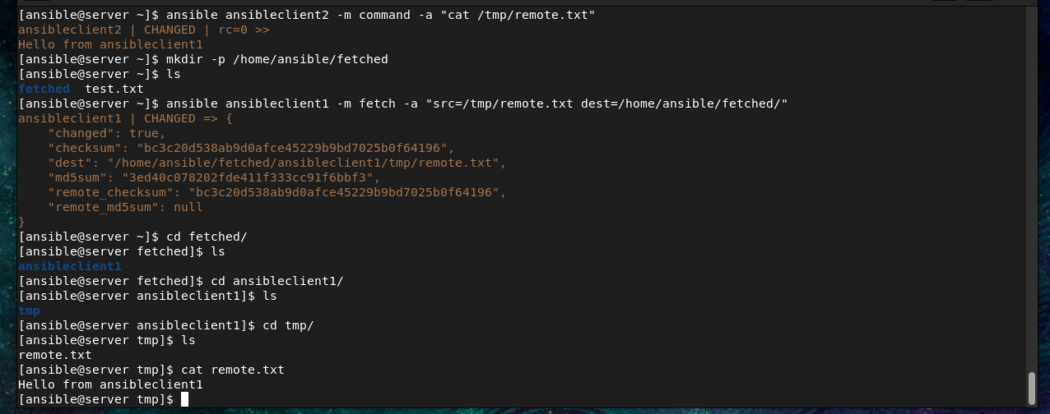

Practical 85 — lineinfile
This practical teaches you how to add one line to a file.
For example, let's add a line to /etc/hosts on both Ubuntu servers.
Run:
ansible dev -b -m lineinfile -a "path=/etc/hosts line='10.0.0.50 myserver'"

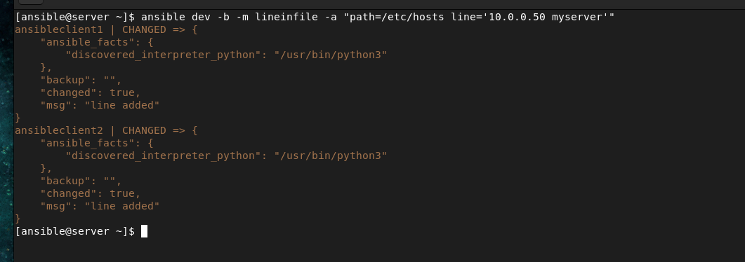

Important
Replace:
10.0.0.50
with an IP address you actually want to use.
-b means become root/sudo.
Why?
Because /etc/hosts is a system file.
Verify:
ansible dev -m command -a "grep myserver /etc/hosts"

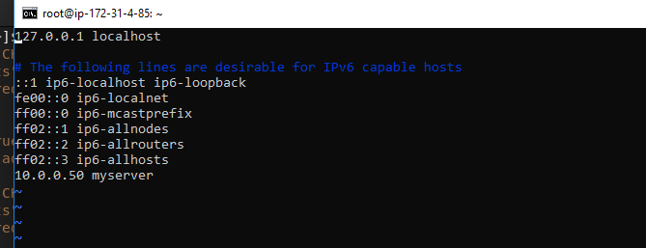

Practical 86 — blockinfile
Now we add multiple lines.
Run:
ansible dev -b -m blockinfile -a "path=/etc/hosts block='10.0.0.50 appserver
10.0.0.60 dbserver
10.0.0.70 webserver'"

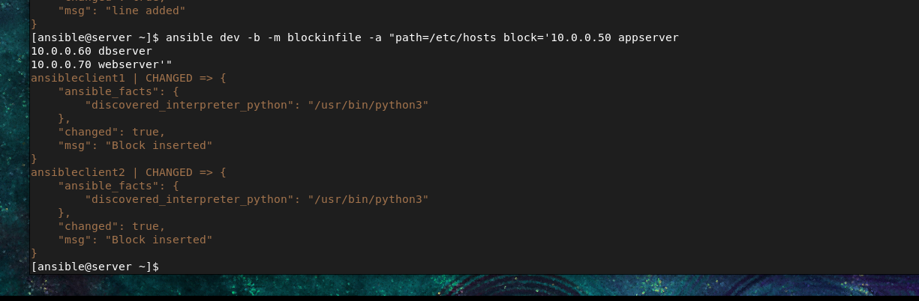
Again, use IP addresses appropriate for your lab.
Verify:
ansible dev -m shell -a "tail -10 /etc/hosts"
You should see something similar to:
# BEGIN ANSIBLE MANAGED BLOCK
10.0.0.50 appserver
10.0.0.60 dbserver
10.0.0.70 webserver
# END ANSIBLE MANAGED BLOCK
